The Effect of Protective Coverings on Solar Panel Efficiency.
Nathan Clements
Advisor: Dr. Peter Monaghan

Abstract
Solar energy is one of the few sustainable energy sources that shows potential for commercial and residential use. As the shift to sustainable energy is being incorporated at the residential level, it is imperative that it become more efficient. As of right now a typical solar module is around 15% efficient at converting energy from the sun into useable electricity. One aspect to the solar panels that could potentially affect efficiency is the protective glass covering its surface. The property of the glass investigated is their ability to retain heat. This property of the glass has shown to perhaps play a part in the panel’s efficiency [1]. If one glass lends itself to increased panel efficiency than others it could help overall energy production. This will help play a factor in making panels more efficient at converting energy from the sun to useable energy in a home. If panels are more efficient, it would be possible to use fewer panels to produce the same energy output. This could both reduce cost and increase the total energy converted. From this study, tempered glass provided the most consistent power output across varying temperatures, making it most efficient.

Introduction
Solar energy has become one of the most popular forms of sustainable energy, especially in the residential sector. The efficiency of these solar modules, or panels, is quite poor at roughly 15 percent which results in more panels needed per system [5]. There is a loss of efficiency both from the sun to the panel, and on a smaller scale, the panels to the inverter. The inverter changes the current produced from an DC current from the panels to AC current that appliances use in your home [2]. The more panels required to meet the energy needed in the project, the more expensive it becomes for the homeowner as well as the installer. In California, every new home must be built with a solar energy source. Since this is clearly the trend across not only the United States, but the entire globe, it is critical to find ways in which the systems can be made more efficient.
The mission of this project is to investigate the efficiency of solar panels that are commonly used on residential homes in the industry today. This will be achieved by collecting data from the different types of protective coverings on the modules. These different protective coverings include tempered glass, laminate glass, and tempered-laminate glass. Data was collected to determine the heat retention of the different materials that would cover the surface of the solar panels. This is used in conjunction with a simulation utilizing LabVIEW software to model efficiency.
It is expected that the heat retention of the tempered glass will be the least when compared to its counterparts. This predication is due to the lack of an interlayer that the tempered glass does not possess. Both other substrates have an interlayer designed to help prevent the glass from shattering, but this will potentially cause it to hold on to heat longer. I expect the tempered glass to perform the best and produce the highest output voltage and therefore be most efficient for covering the solar panels.

Theory
To prevent from too many changing variables, the open current voltage output of the panels was the focus for experimental data. This was utilized to calculate the fill factor, or FF, which is done in the simulation using equation (1) below [3].

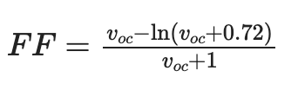
(1)

The open circuit voltage is labeled as Voc and is measured by utilizing a voltmeter. The open circuit voltage is recorded from the panels themselves and input into the simulation. Once this fill factor has been determined by the simulation it calculates the maximum power, Pmax, which is done through equation (2) which is seen below [3].
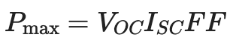
(2)
This utilizes the open circuit voltage, the previously calculated fill factor, and the short circuit current to calculate the maximum power value. The short circuit current is used as a constant which is given by the manufacturer. Following the calculation of the maximum power output, the simulation utilizes equation (3) to calculate the efficiency of the panel [6].
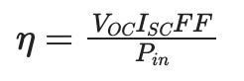
(3)

This efficiency will change based on the voltage recorded of the panels with each substrate placed over the panels. For both types of panels each substrate was utilized, and its efficiency calculated.
It is important to compare the voltage output with the substrates to the output of the panels by themselves. To do this the open current voltage with the substrate covering the panel is divided into the open current voltage with nothing over it. The open current voltage with nothing protecting the panel will always be the highest value as nothing is restricting it. This calculation will provide the percentage of the new voltage to its potential in that moment.

Methods
The construction of this project included two different solar panels and three different covering materials. In addition to the use of the solar panels and substrates a LabVIEW simulation was created and utilized to determine the efficiency of the panels. Data was collected to determine heat retention of the substrates, and the voltage output of the panels on their own as well as with the substrates covering them. The LabVIEW software was downloaded to a personal machine. There are several different versions, but the freely available software was sufficient for the uses of this project [4].
The first phase of data acquisitions only required the three different protective coverings. The three glass substrates are tempered glass, laminate glass, and tempered-laminate glass. These were tested for their ability to retain heat. This heat retention was determined by placing the coverings outside and recording the values of their temperatures using a non-contact thermometer every ten minutes. The more that the substrate retains heat the, faster it will heat up and the higher the peak temperature will be.
Once this had been tested effectively the panels were used to take data regarding their output voltages. The control point of the panels was measured by simply placing the panels out during the day and recording the open circuit voltage. When the control for the panels had been determined, the coverings were tested one by one on their effect on the open circuit voltage output. These values were recorded by utilizing a voltmeter which can measure the voltage of the circuit contained in the solar module. These voltages were then compared to the control to see the effect of the substrates on the output voltage and therefore efficiency of the panels.
The data was then compiled into a Microsoft Excel sheet where it was graphically portrayed to make the trends in the data more accessible. The graphs show the voltage output with the substrates compared to the maximum voltage with no covering. These graphs also compare the percentage of the maximum voltage output as a function of the substrate temperature. This shows the trend of the voltage output as the temperature of the substrates increase. The graphs are also separated by the monocrystalline panel and polycrystalline panel to add an extra layer of precision to the data.

Data
Graph 1:

Graph 2:

Graph 3:

Graph 4:

Discussion and Conclusions
Each of the graphs have been broken down by the solar panel type used. The monocrystalline panel had a larger surface area and therefore provided a higher voltage output. This higher voltage output led to a higher efficiency percentage. If the panels had been the same size, then the voltages and efficiencies would have been much closer. The larger voltage output for the monocrystalline panel is what caused the larger gaps in the efficiencies. Those data points were more significant due to the more substantial differences in values. Much of the polycrystalline panel data was too close to draw any concrete conclusions on.
Graph one is a graph of the voltage output of each substrate covering the polycrystalline panel as a percentage of the voltage with nothing covering it. This also is a graph of increasing temperature of the substrates from left to right. Both the laminate and tempered-laminate glasses provided larger voltage outputs at the lower temperatures. They then both decreased their output as the temperatures got to their highest values. The tempered glass was relatively unphased over the increase of temperature. This is very appealing as during hot summer days the substrates can reach temperatures well over one-hundred degrees Fahrenheit. The more consistent the voltage output is during the temperature change, the more beneficial the substrate is for the system over-all.
Graph two is the same layout as graph one but for the monocrystalline panel. For the monocrystalline panel the story is more of the same. The tempered glass provides the steadiest voltage output over varying temperatures while the other two substrates are negatively affected by the top end of the temperatures.
The third graph is a graph of the calculated efficiency through the LabVIEW of each substrate compared to the efficiency without a covering. Each “Trial Number” is a data collection step where each of the voltages were recorded at the same time. This is for the polycrystalline panel once again. These efficiencies are extremely close to one another but there are trends that are worth pointing out. Laminate glass was the least efficient of the three with the other two glass types being the better options. This ties into the earlier graphs which showed that Tempered glass produced the highest output voltage most often for the polycrystalline panel. This graph shows that the efficiency follows that same pattern, making it still the best option.
The fourth and final graph is the same design as graph three but for the monocrystalline panel. Once again, the tempered glass yields the highest, and most consistent efficiencies. Over the trials that were run it was most frequently the highest value of efficiency compared to its other two counterparts.
The tempered glass was the most simplistic glass of the three chosen. Both remaining substrates have an interlayer of material which resulted in greater heat retention. This heat retention ended up having a negative correlation on both the output voltage and efficiency of the solar panels. If it were possible to extend this project it would be worthwhile to investigate the effects of these substrates during the summer months when temperatures are more extreme. Investigating the performance of the panels in the winter months when it is much colder could be beneficial as well. It would also be beneficial to investigate the results of full sized residential solar panels. These lower voltages produced from the small panels yielded results that were close to each other. The gap in the efficiencies may be greater with larger panels creating more power. Stronger and more decisive conclusions could potentially be drawn if a full-sized panel was used. In addition to this it would also be interesting to investigate the role the inverter plays and how much power is lost in that part of the solar energy process. This loss in energy is much less substantial but still very interesting to investigate. Or, if not looking into the inverter, investigate DC run appliances that are now available on the market. All homes are set up now to run on AC but if DC appliances were used then you could bypass the inverter and go straight from the panels to the home.
From the data collected in this experiment trends were established that show that the tempered glass was the most consistently efficient. However, to say with certainty which substrate is most efficient to protect solar panels, further research would need to be conducted. This is because of the very close voltage outputs and efficiency values that were mentioned earlier. With larger and more powerful panels the effects would be seen on a larger and more definitive scale.

Appendices
Shown below (Figure 1) is the block diagram of the simulation created to calculate the efficiency of the solar modules. I can manually change any of the values and it will calculate the efficiency. The factor I have been changing is the voltage because that is what is found throughout data collection [4].
Figure 1: LabVIEW Block Diagram
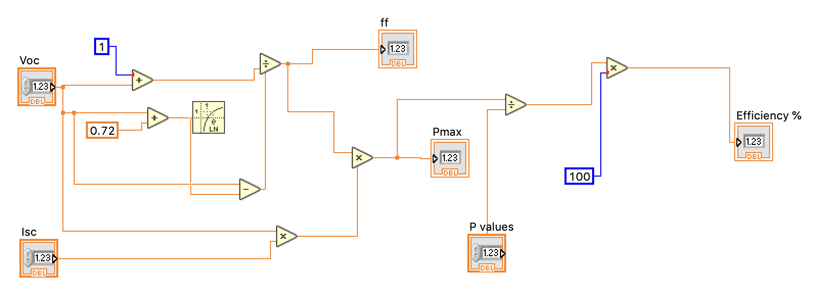

Figure 2: Polycrystalline Panel

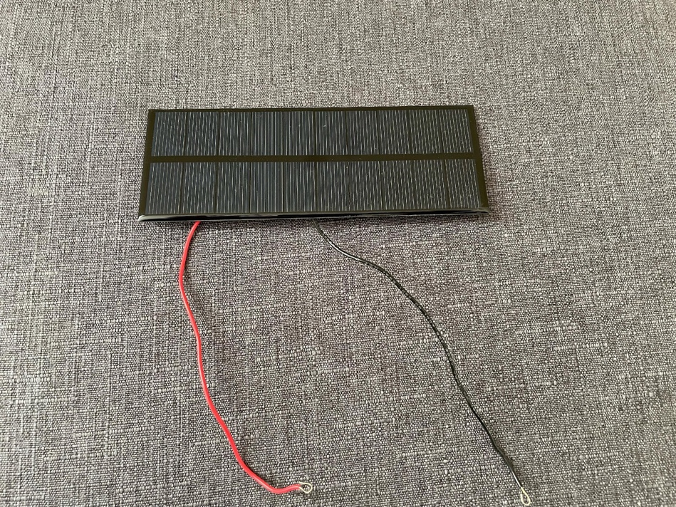

Figure 3: Monocrystalline Panel
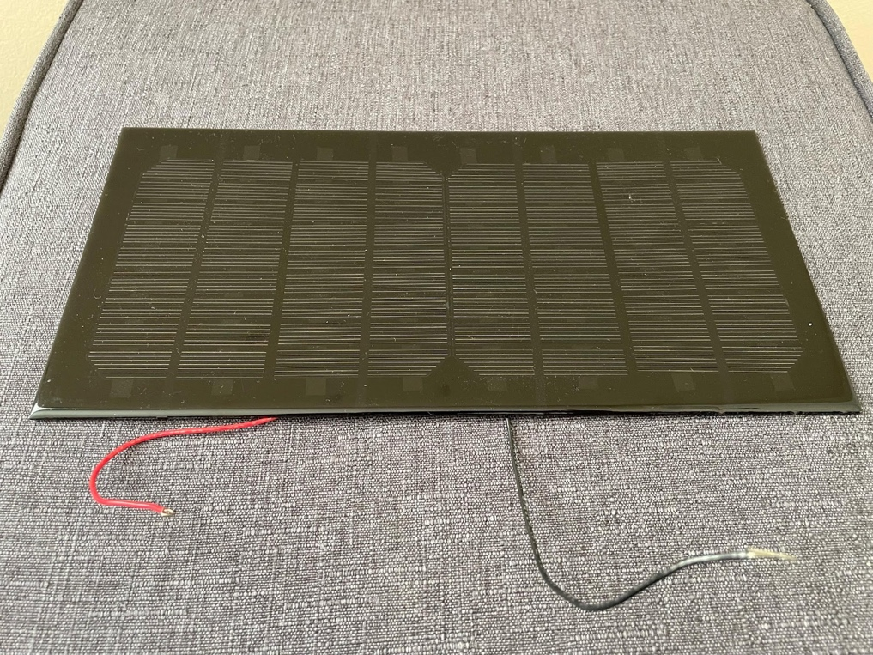

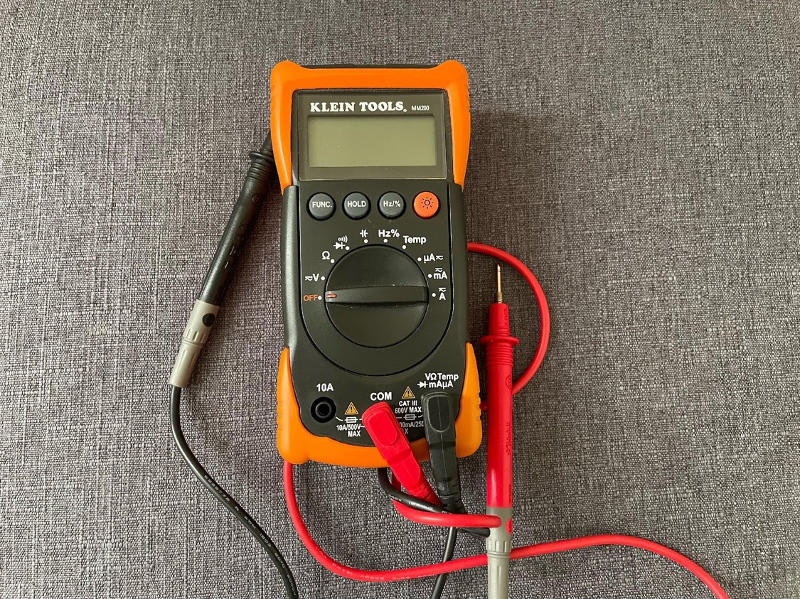
Figure 4: Voltmeter

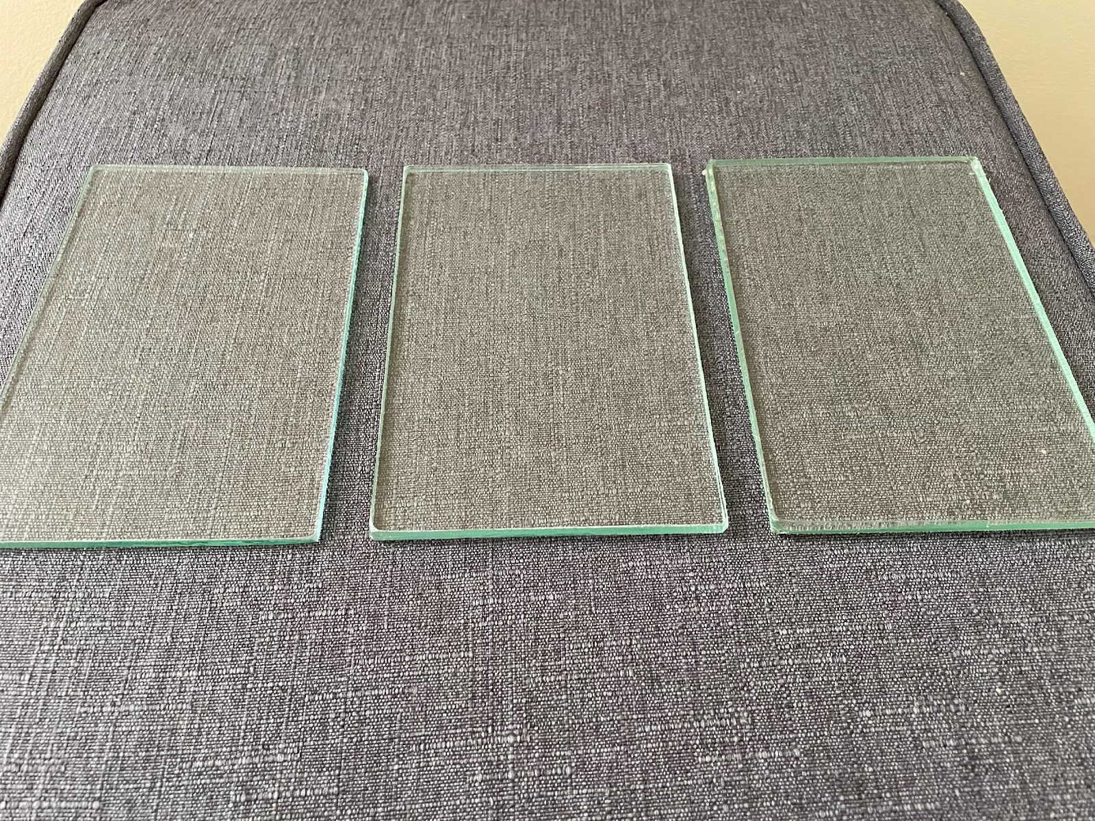
Figure 5: (Left to Right) Tempered Glass, Laminate Glass, Tempered-Laminate Glass
Figure 6: Contactless Thermometer

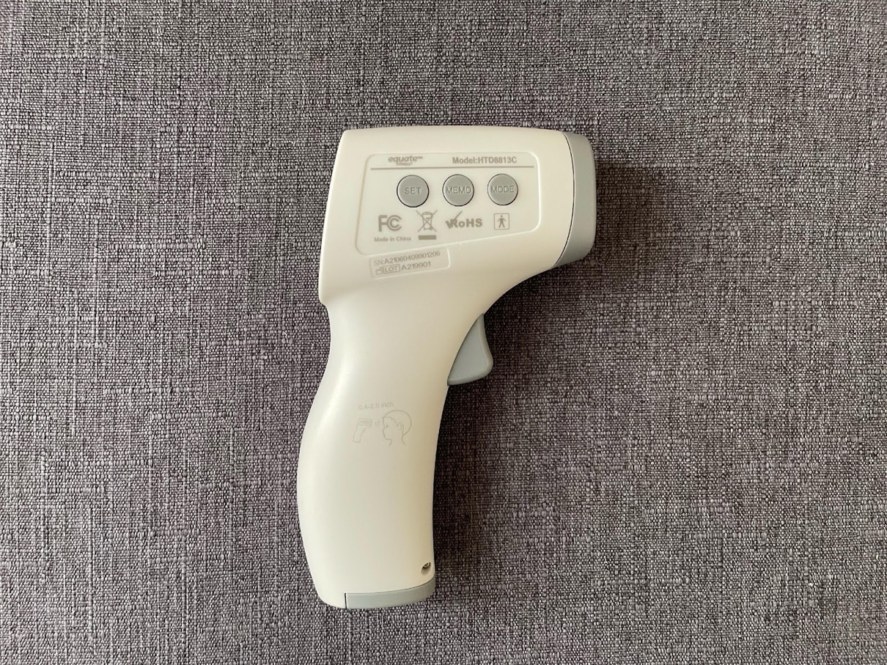

References

[1] Author, K. Ferner, “Investigating Photovoltaic Solar Cells for Efficiency Im-
provements”, 2020-2021
[2] Bisquert, J. (2020). The Physics of Solar Energy Conversion. https://doi.org/10.1201/9780429505874
[3] Green, M. A., & Jain, A. (n.d.). Fill factor. PVEducation. Retrieved February 3, 2022, from https://www.pveducation.org/pvcdrom/solar-cell-operation/fill-factor
[4] J. A. Jaleel, A. Nazar, and A. Omega, “Simulation on maximum power point tracking of the photovoltaic module using labview”, International Journal of Advanced Research in Electrical, Electronics and Instrumentation Engineering 1, 190–199 (2012).
[5] Office of Energy Efficiency & Renewable Energy. (n.d.). Solar Photovoltaic Cell Basics. Energy.gov. Retrieved February 12, 2022, from https://www.energy.gov/eere/solar/solar-photovoltaic-cell-basics
[6] Solar Cell Efficiency. PVEducation. (n.d.). Retrieved February 3, 2022, from https://www.pveducation.org/pvcdrom/solar-cell-operation/solar-cell-efficiency

